Prototype 3:
Key Features of the Smart Campus Companion App
• 2D Smart Campus Navigation – Live indoor and outdoor navigation with floor-wise views and classroom-level accuracy.
• Class-Based Auto Navigation – Automatically guides students to the next scheduled class based on their timetable.
• Role-Based Dashboards – Separate, purpose-driven dashboards for students and faculty.
• Faculty Availability & Appointments – Real-time faculty status with structured appointment booking.
• Centralized Announcements System – Category-wise academic, exam, and event communication in one platform.

Prototype link:

https://agile-campus-guide.lovable.app

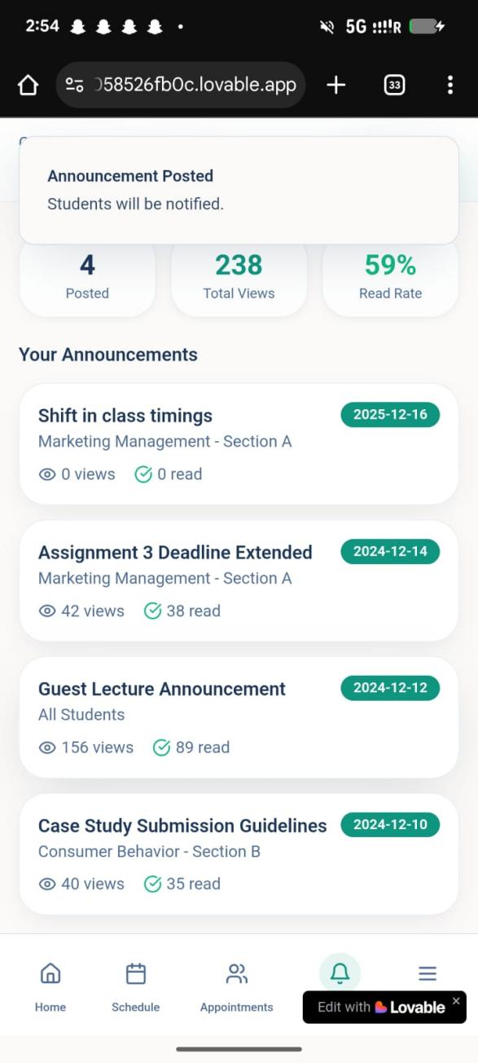
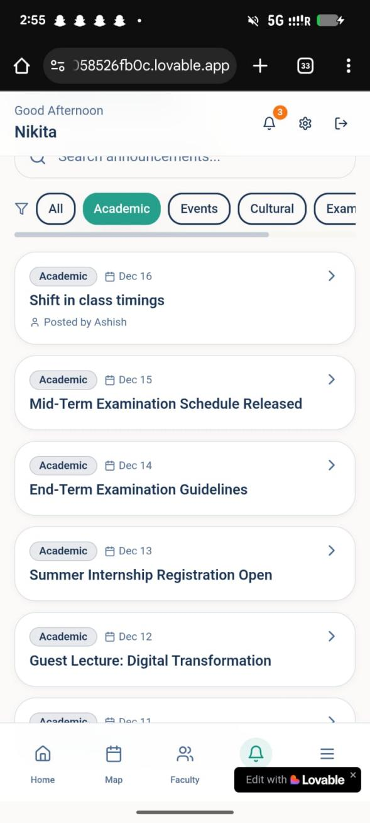

Feature: The faculty can make an announcement, which could be accesed by the students!

Prototype 2 (Left) vs Protype 3 (Right)
Image 2: Dashboard. Prototype 3 come with integrated college ERP and LMS( Quick Links), which was a suggestion by the users of prototype 2.

Image 1: Login page.
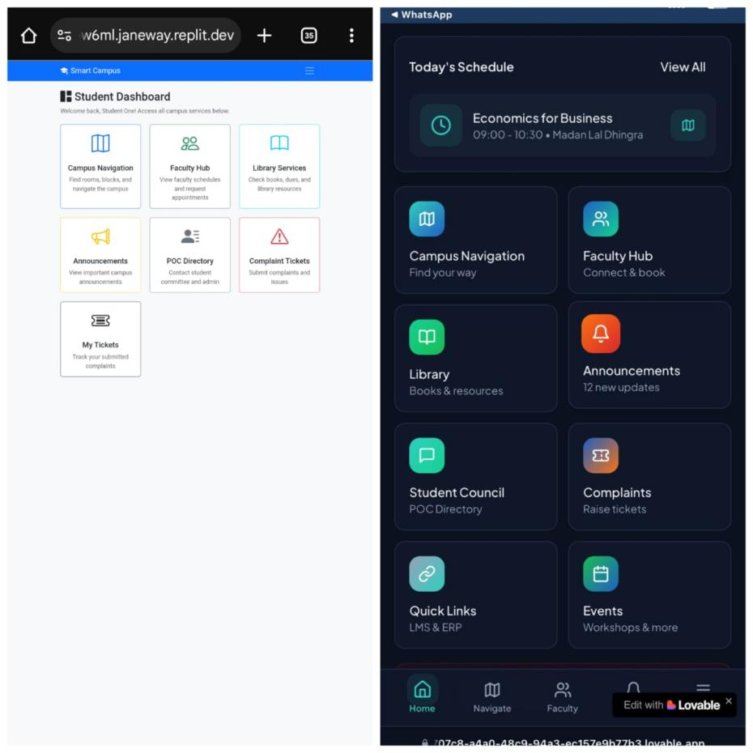
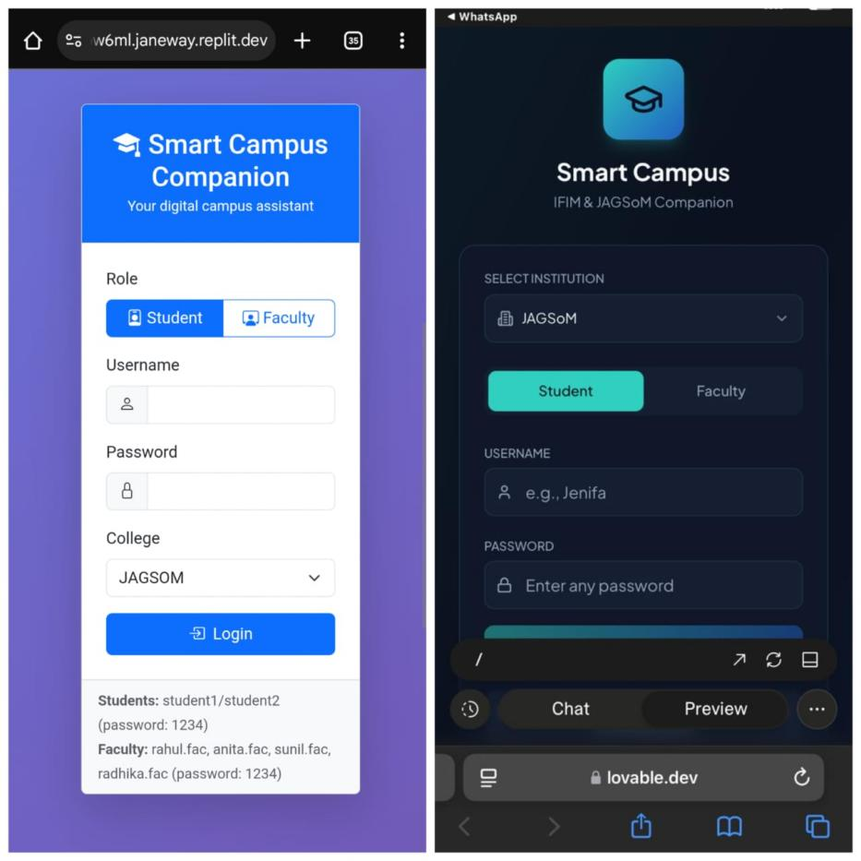

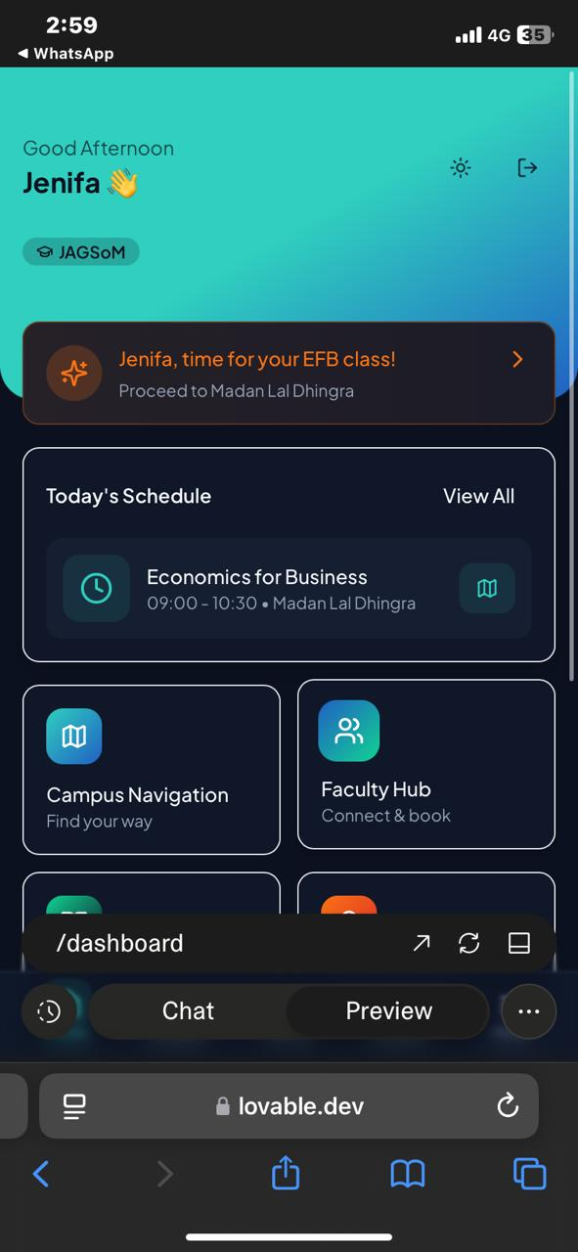
Image 3: Customized navigation, a feature that would remind the student about their schedule and venue. (Prototype 3)

